Setting up GitHub for python projects:

Requirements:

1. Install Git bash including Git GUI
2. Github account

Steps: GitHub First approach

1. Create a repository on your GitHub account. No need to create any files.

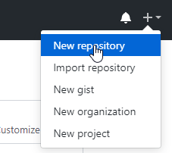

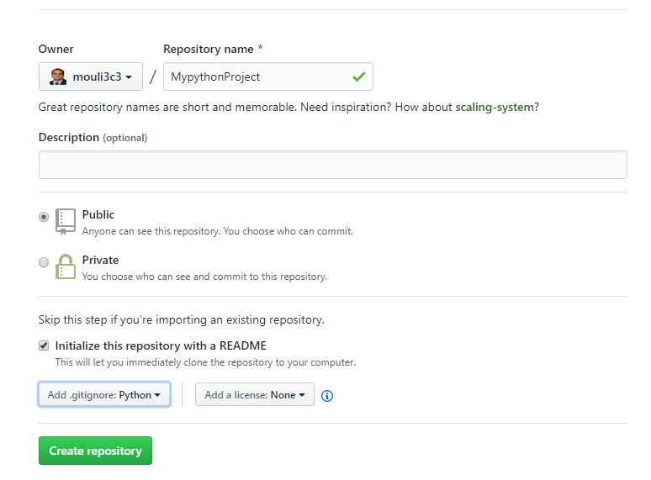

1. If we want to clone on to our PC using HTTPS:

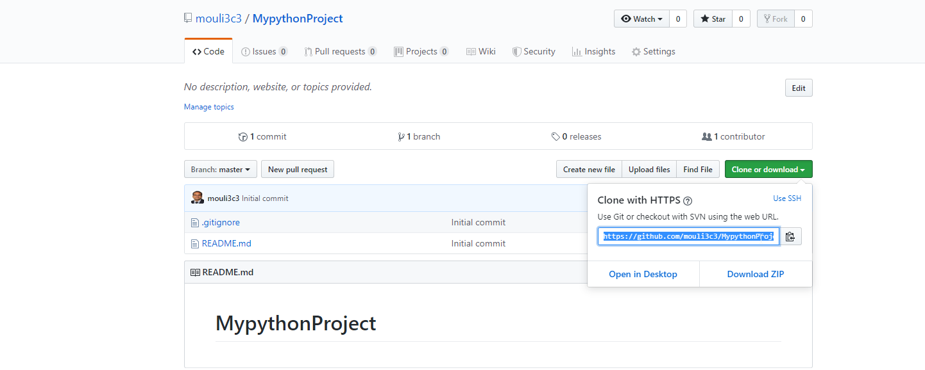

1. Starting with Git Gui

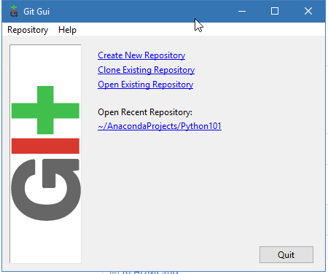

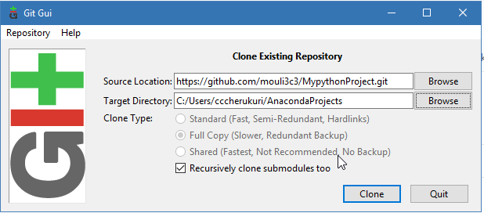

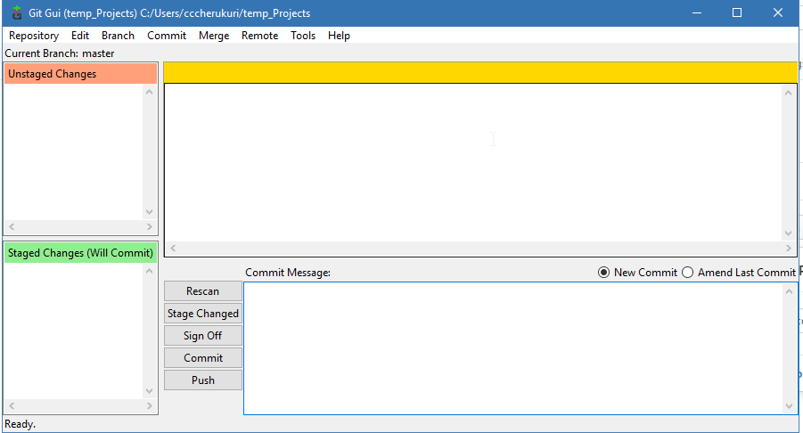

1. Ready to make changes and push your code to Github

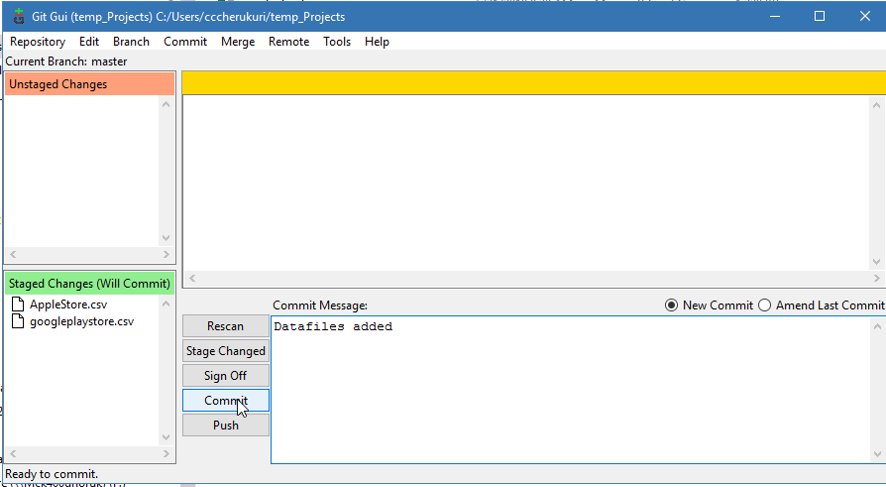

PUSH

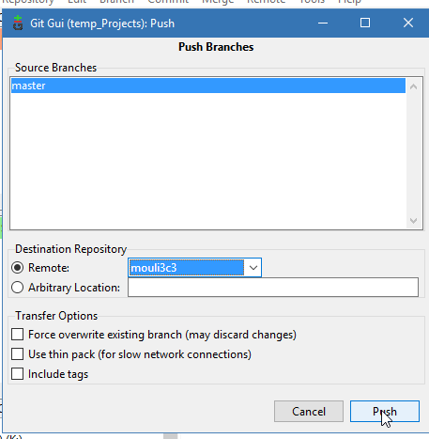

Before Pushing;

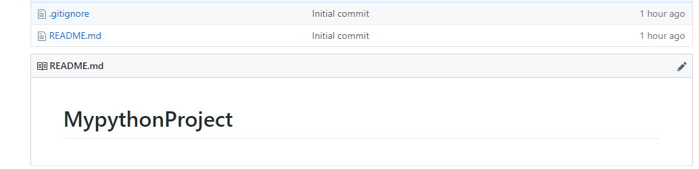

After Pushing:

